Each year the Dodgers break my heart, I write up a season recap exploring what went right and just where things turned sour. As I was writing this year’s bombshell, there was this itch to talk about a certain pitcher: Clayton Kershaw. I tried to avoid ranting about him in the recap, but that itch just kept coming back, like the 1 or 2 sentences I said about him didn’t do him justice; a player who was utterly hitless for 6 years had just imploded and became the villain. I’m gonna preface this saying Kersh is a stand up guy, a family man, and a fellow brother in Christ and nothing I say changes that. So how did this future 1st ballot HoF suddenly fall of Mount Everest?

Before we look at what Kershaw has become, we need to look at (and appreciate) Kersh at his best. I don’t think you appreciate just how godlike Kershaw was during his prime. If you don’t believe me, let’s look at his numbers. Between 2011-2016, Kershaw won the Cy Young Award 3x (2011, 2013, 2014), 2x NL Wins leader (2011, 2014), 4x (OH MA GOSH) ERA leader (2011-2014), 3x NL Strikeout leader (2011, 2013, 2015), oh and add won the triple crown in 2011, and why not, won the MVP in 2014 while pitching his only no-hitter that year NBD. These accolades are huge, but I argue that the numbers are even more staggering. During that 6 year stretch, Kershaw posted a 2.04 era, IN 6 SEASON, over 1500 innings pitched (1510.1 if you’re wondering). Remember when I said he was unhittable? Well stats supports that too. He had a 0.908 WHIP in those 6 seasons, pretty much meaning less than one person would get on base per inning. He also average 10.0 strikeouts per 9 innings too fyi. Oh, and the HR trouble you see Kershaw in now, well back then he had a HR/9 of 0.5, which statistically means that you’d have to go to 2 Kershaw games before you see him give up 1 Homerun. These stats are insane, but let’s look at him when he was arguably at his greatest: 2014.

9. 9 is the amount of homeruns that Kershaw had allowed all season, leading to a HR/9 at 0.4, so you’d better go to 3 Kersh games before he gives up a homerun. He led the league, not the national league, ALL OF BASEBALL in 8 pitching categories: ERA (1.77), Wins (21), W-L % (87.5%), Complete Games (6), ERA+ (197), FIP (1.81), WHIP (0.857) (Justin Verlander threw around this in 2019), and SO/9 (10.8). As a reference, Kershaw led all of these categories by at least 1 significant figure over the AL Cy Young Award winner Corey Kluber. Kersh was utterly dominant, but just how did he accomplish this feat? Kersh followed a strict formula using his arsenal of pitches. He started most at bats the same: a bullet (refers to the movement not the speed) fast ball on the right side of the plate. (Scroll Down)

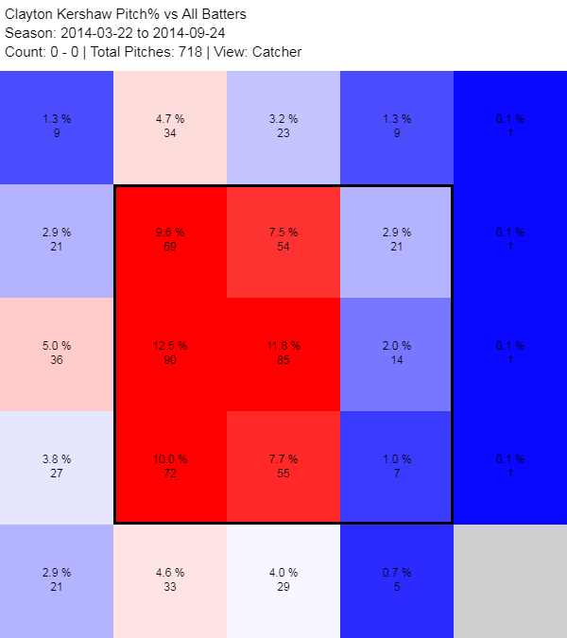

This is a heat map of Kershaw on the first pitch. He starts his at bats with a strike 67% of the time (led the MLB) as a way of getting ahead in the count.

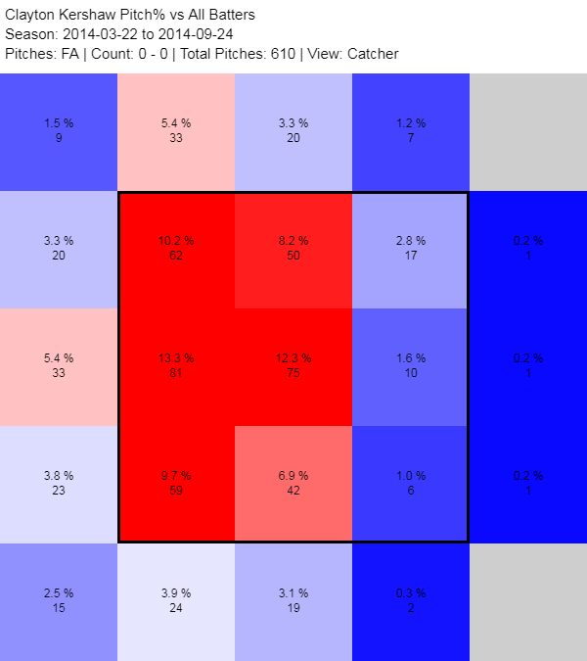

This heat map shows the % of that fastball. Of the 67% strikes, 66% of them were off of his fastball. Now head in the count, Kershaw had his whole arsenal of 3 pitches to go to: his nasty slider, the 12-6 curve, or back to the fastball. This typically led to him getting to that whatever-2 count, setting him up for his slider, and sometimes his curve down the middle.

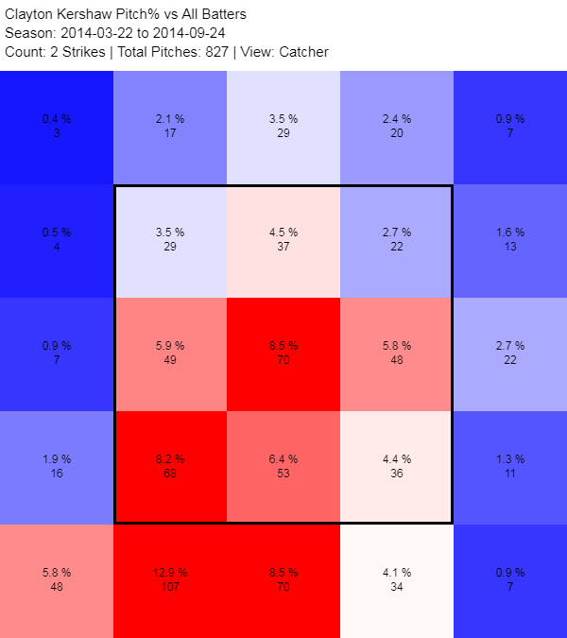

You see him favoring the bottom part of the zone with that slider, and homie would chase that day in and day out (aside the hotspot in the middle, das his curve at work). This was Kersh’s bread and butter.

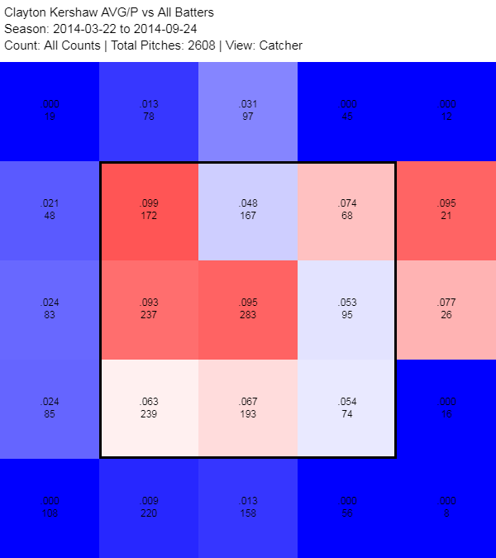

Everyone was struggling to get a hit off Kershaw. No where on this map did batter ever bat more that .100. That is what utter dominance looks like, before the injuries sets in.

It’s important to know that back in 2014, Kershaw was a hot (and sexy) 26 year old pitcher, throwing his fastball at 94, slider at 89, and a curve that ranged anywhere from 76 to 73. In 2017, Kershaw was hit with a mild herniated disc and was shut down for 60 games that season, his first major injuring the in the big leagues. Then in 2018 he was diagnosed with left biceps tendinitis followed by another stint with back pains. This year too, he had left shoulder inflammation, preventing him from pitching opening day, which would’ve been his 9th year doing so. Kersh’s body has tacked on alot of baggage since his youth and now, at 31, it’s almost like looking at a shell of his former self. Let’s take a look at how Kershaw had changed this year.

Kershaw’s 2019 season is far from bad, but not good when you’re talking about one of the greatest pitchers of all time. Kershaw’s line included a 3.03 ERA, his first time over 3 since his rookie season in 2008 (a freaking 11 year stretch) with a respectable 1.043 WHIP. The biggest problem, however, was, of the course, the homeruns. Remember how many homeruns he gave up in 2014? 9. In 2019, Kershaw more than tripled that number at 28 homeruns, good for at least 1 homerun per game. Back in those days, seeing Kersh give up a homerun was like finding a unicorn, now it’s a frequent as a Donald Trump tweet. I won’t go into the juiced balls, cause both [Justin Verlander](https://www.cbssports.com/mlb/news/justin-verlander-blames-mlb-for-juiced-balls-home-run-spike-major-league-baseballs-turning-this-game-into-a-joke/) and [Rich Hill](https://www.usatoday.com/story/sports/mlb/2017/04/17/rich-hill-dodgers-blister-disabled-list/100586160/) has put their two cents into the matter. What I’m interested in is what changed in Kershaw.

Like I said, Father Time has not been kind to young Clayton. All those injuries have taken its toll on his body, and, as a result, his velocity. His fastball dipped from 94 to just above 90. To put that in context, it takes a 95MPH fastball about 387.5 milliseconds to reach home plate. Compare that to 400 milliseconds on a 90MPH and the batter has a whole 12.5 milliseconds more to make a decision to swing or not. It doesn’t seem like a lot by itself, but in the context of baseball, every millisecond counts and could be the difference between winning or losing the game. His signature slider, the go to pitch, took the biggest hit of all. The hard, nasty slider that was at 89/90 dropped to 87 average, even as low at 85 on bad days. The curveball dropped in the velocity too (75 average - 73), but that doesn’t matter as much since its a pitch that’s about movement and location more than speed.

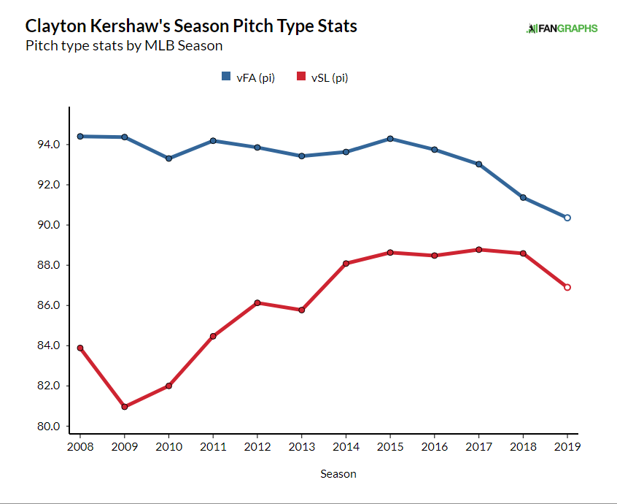

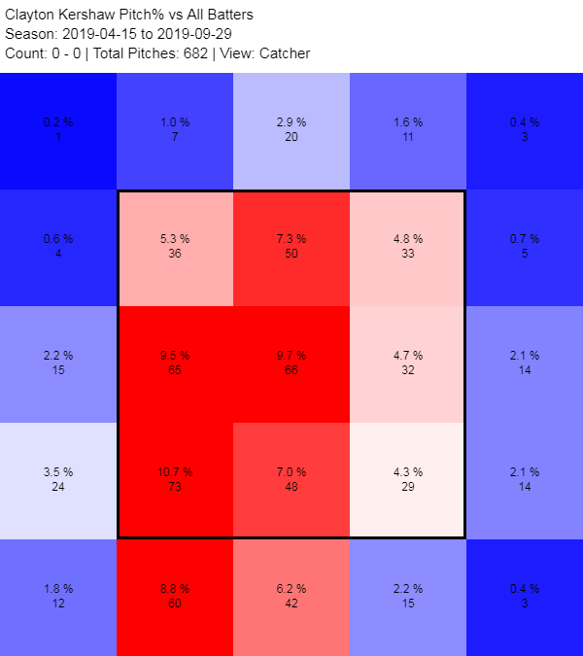

For the most part, Kershaw still hit the zone on the first pitch. Again attack with his fastball on the first pitch, but this time staying low in the zone. Losing velocity on his fastball means that he can’t challenge hitters at much as he did when he was younger, staying more out of the zone that before. Also, he relied more on his slider to open the count than before, using it about 20% of the time compared to 12% on a 0-0 count. The problem was, however, even if Kershaw was ahead in the count, he seemed to fall behind more than ever this season. He was placed in a situation was behind 541 times, striking out those in a something-2 count 46% of the time, again compare that to 2014 where in those same situations, batter were striking out 57% of the time. The fact was, Kersh could get the strikeout, he just had to work harder for them. So why weren’t batter biting on the slider/curve combo anymore?

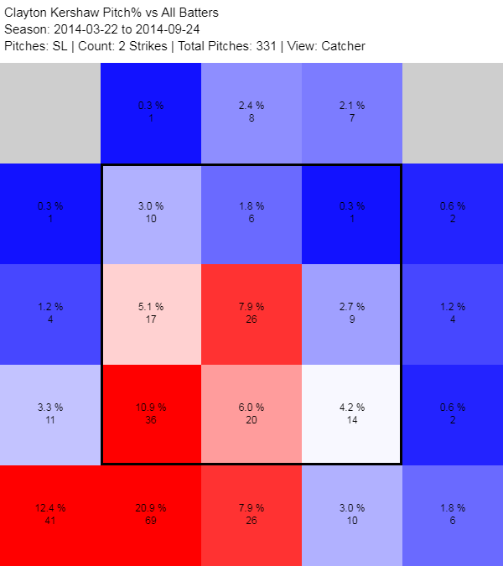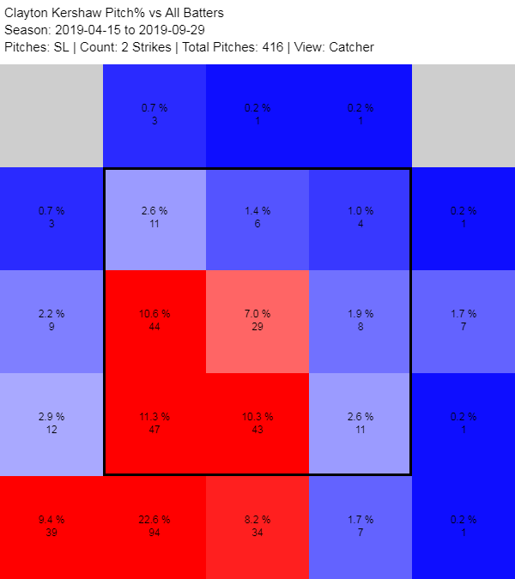

The left shows the dominance of the Prime Kersh Slider, a ball that sweeps like a fastball then breaks down into the corner or below the zone and paints that corner like Picasso. Now look at the numbers on the right. Kershaw is still hitting the zones he wants to, but his slider is hanging. It now dominates the middle and lower middle of the zone, a prime spot for hitters. What was Kersh’s signature and finishing pitch had now become his kryptonite. Both of the pitches thrown at Rendon and Soto in the NLDS were sliders, one with predictable break and the other that hung in the zone.

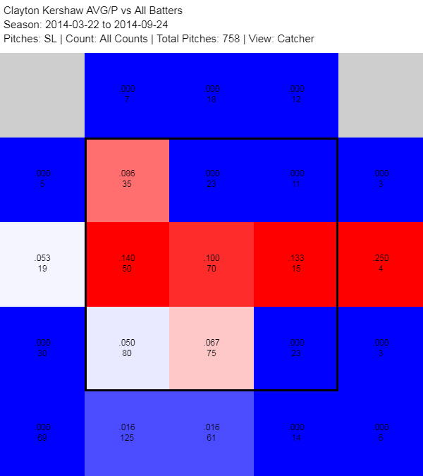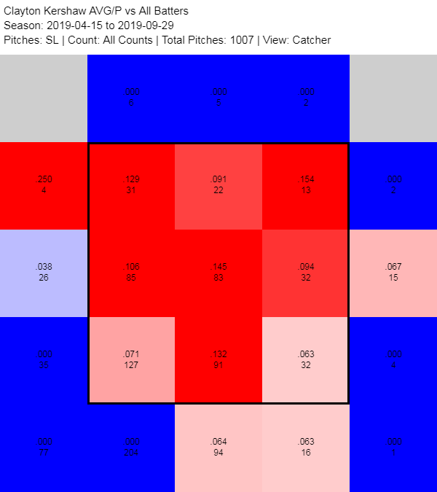

On the left is 2014 batter’s averages against his slider. The only hot zone was in the middle (and the 1 hit on the right… how’d they hit that?), as those were hanging sliders. Even then, there were barely anyone hitter those balls and if the did the damage was abysmal. Prime Kersh limited the times he lost control and threw a hittable slider, only about 22.4% of the time. Now lets look at this hot mess that is 2019 Kershaw’s slider on the right. You can see the stark contrast in where the ball is hitting, or in this case missing. (actually hitting is the right word). The lack of movement and velocity can really be seen here, as the rate of him throwing a “hittable” slider is around 35.8%, a dramatic increase. This leads to more hits, more homeruns, and more [sad Kershaw.](https://sportshub.cbsistatic.com/i/r/2019/10/10/feb5dfdd-0aea-4d35-8ab9-08c81b0cd711/thumbnail/1200x675/da3909b05c39d3d41ef247896770c353/clayton-kershaw-sad.jpg)

His curveball hasn’t been too hot either. It was said that he was reluctant to go to his curveball this season, but he actually threw it more than any season before (421 times) compared to his MVP 2014 season (373 times). The problem, though, wasn’t his reluctance, it was his confidence. In that MVP season, there were only 16 hits again the curve, while here in the present, 20 of them were hits with 4 being homeruns, the first time in his career.

I’m not gonna talk about postseason Kershaw, you have already seen it firsthand. A man, or rather, a legend with a career 2.44 ERA in the regular season degraded to a 4.43 ERA with a 45% W-L% is just sad. My assumption is that he can’t handle pressure, though I can’t support that with numbers. Regardless, I love Clayton Kershaw. He is an amazing pitcher who’s bad seasons are easily better than you average good seasons. He will undoubtedly be a HoF and even a Legend of Dodger Baseball, but right now he’s arguably the 3rd best pitcher on this team (2nd if Ryu leaves). Kersh’s problem is that he’s pitching the same way as he has been for the past 11 years. While the idea worked in the past (get ahead in the count and punish the batter), his body and mechanics couldn’t keep up. I really hope he changes him game for the better and he rebounds next season; any Dodger fan should want that for their ace. Kersh has had an amazing career, all that’s missing is that ring and even if he blew this season, I really want him to win it all.

That being said, we won’t/can’t trade Kershaw. 1) Understand that we were able to get the division title year after year because of his solid pitching. Hell, we even got to the WS twice because of him too. Before y'all can think about how effective he’ll be in the postseason, remember that it takes a team of aces to get there in the first place. 2) His contract is too damn expensive. He’s getting paid max contract money and many of the small market teams can’t take that commitment, especially those last offseason who paid stupid money (I’m looking at you San Diego, Philadelphia, Anaheim, and Colorado). How about if you wanna trade someone, you trade JOE KELLY AND AJ POLLOCK, they butchered the team worse than Kershaw yet I don’t hear as much jaring for them as for Kersh.

Love ya Kersh. Keep your head up high.

